Task 1:

What is good code vs Bad code ..

Good code:

- Follows SOLID principles.
- No long classes, methods and parameters.
- No complex nested loops.
- Follows DRY, kiss and YAGNI principles.
- Easy to test.
- Easy to maintain.
- Uses proper exceptions and error handling mechanisms.
- Uses proper naming conventions of variables, classnames and methodnames.

Bad code:
- Has long classes with complex methods.
- Long parameters.
- Doesn’t follow SOLID, DRY or YAGNI or any of the principles.
- Difficult to test and maintain.
- Doesn’t use proper exceptions and error handling mechanisms.
- Uses proper naming conventions of variables, classnames and methodnames.

Task 2:

BAD CODE vs GOOD CODE - ORAL

Task 3:

What do you understand by databinding?

Data binding is a mechanism that connects UI elements to data sources, enabling automatic synchronization between the data and its visual representation. It allows developers to create dynamic and responsive user interfaces where changes in the data are automatically reflected in the UI, and vice versa, without manual DOM manipulation.

Task 4:

What do you know about continuous development?

The ongoing process of refining and improving software by incorporating frequent changes, testing, and releases. It's a key aspect of modern software development, especially within Agile and DevOps methodologies, emphasizing iterative improvements and rapid feedback cycles.

Task 5:

What are the conditions for polymorphism?

Key Conditions for Polymorphism:

1. Inheritance:
Polymorphism relies heavily on inheritance, where a class (subclass or derived class) inherits properties and behaviors from another class (superclass or base class).

2. Method Overriding (or Dynamic Binding):
This is where the subclass provides its own specific implementation of a method that is already defined in the superclass. When the method is called on an object of the subclass, the subclass's version is executed, not the superclass's.

3. Method Overloading (or Static Binding):
This allows multiple methods with the same name but different parameters (number, type, or order) to exist within the same class. The compiler determines which method to call based on the arguments provided at compile time.

4. Common Interface:
Objects from different classes can be treated as if they belong to the same type (e.g., through a shared base class).

Task 06:

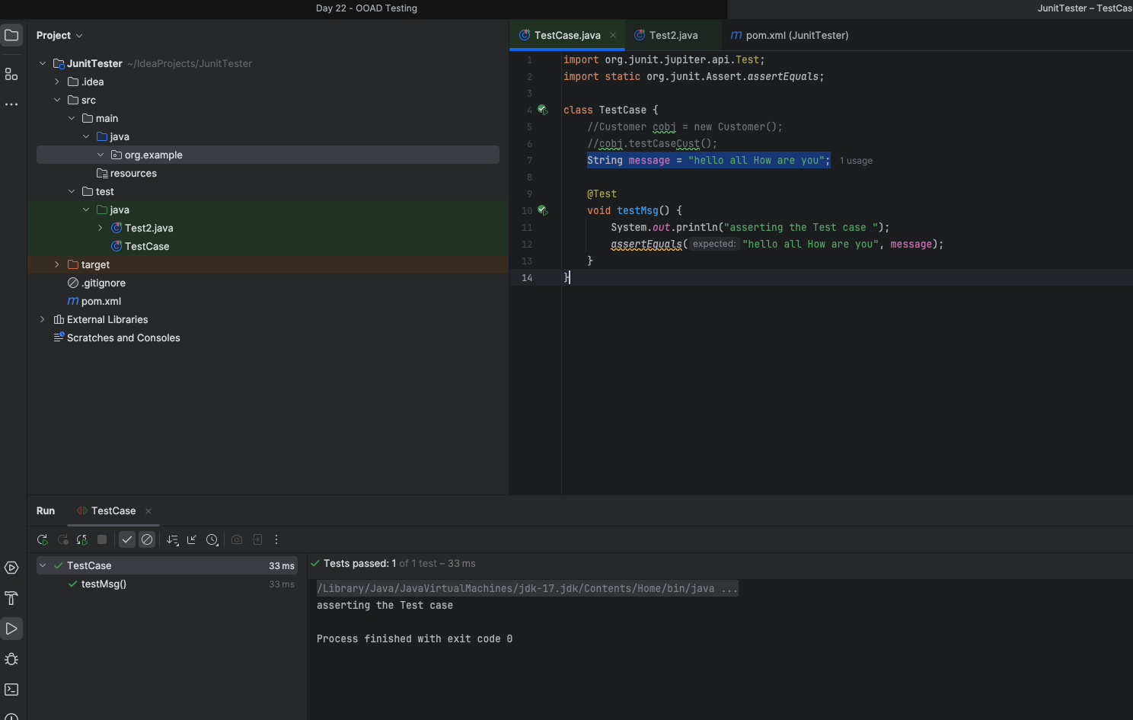

Task 07:

import org.junit.jupiter.api.Test;
import org.junit.jupiter.api.Tags;
import org.junit.jupiter.api.Assertions.assertEquals;
class TestCase02 {
@Test
@Tags("firstPriority")
void testMethod01() {

}

@Test
@Tag("firstPriority")
void runTestcase02() {

}
@Tags("fastTag")
void testMethod03() {

}

@Test
@Tag("slowTag")
void runTestcase04() {

}
}

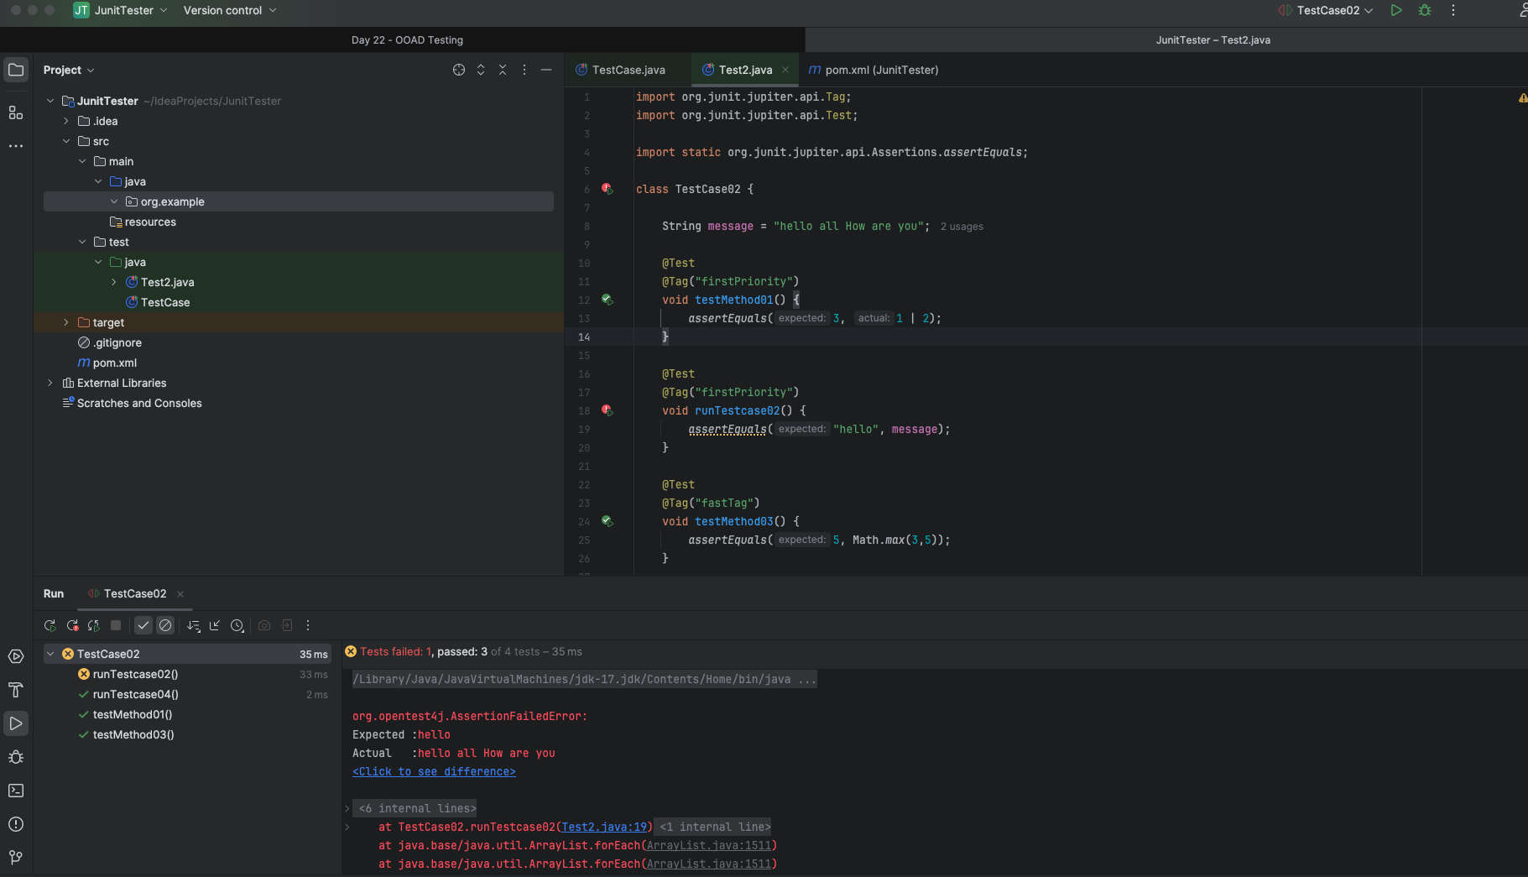
Task08:

Write a test case for the below java file

public class Junit4Test {
public int compare(int n1, int n2) {
if (n1 > n2) return 1;
return -1;
}
}

Test case for your ref

public class Junit4TestCases {
@Test
public void compare() {
Junit4Test obj = new Junit4Test();
int value = obj.compare(20, 10);
Assertions.assertEquals(10, value);
}
}

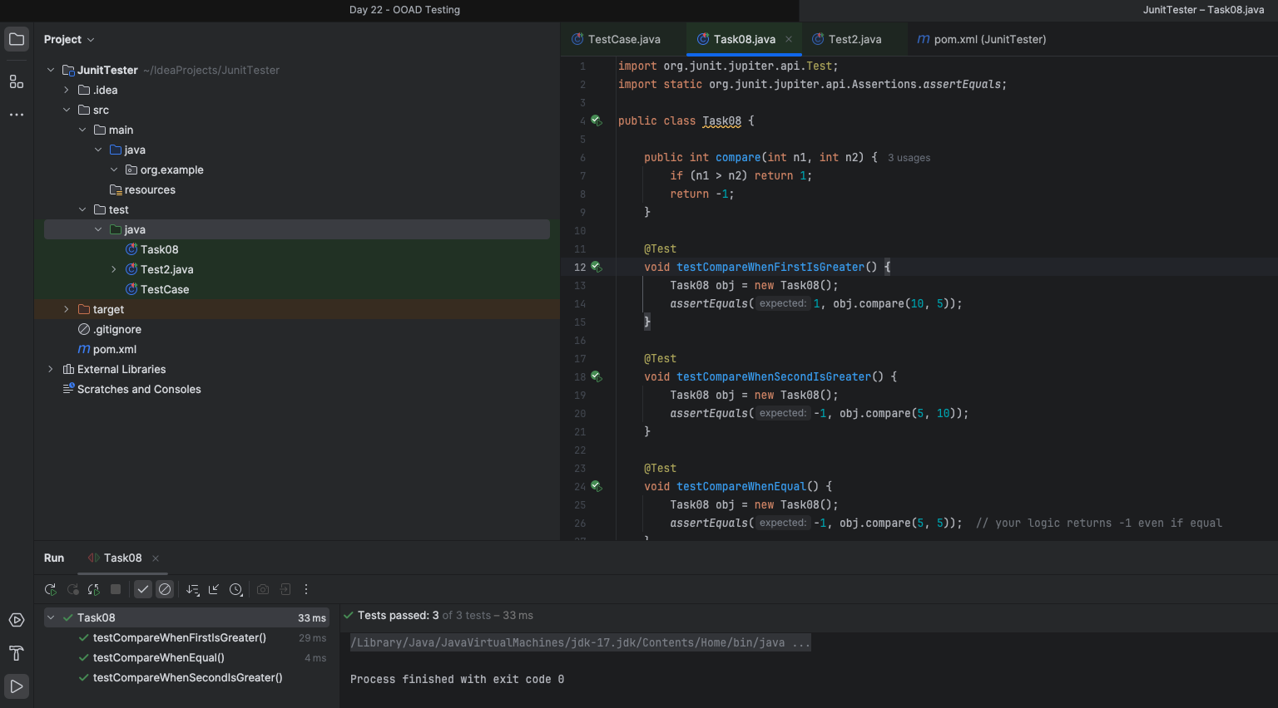

Task 09:
Write test case for below code

public int compare(int n1, int n2) {
if (n1 > n2) return 1;
else if (n1 < n2) return -1;
return 0;
}

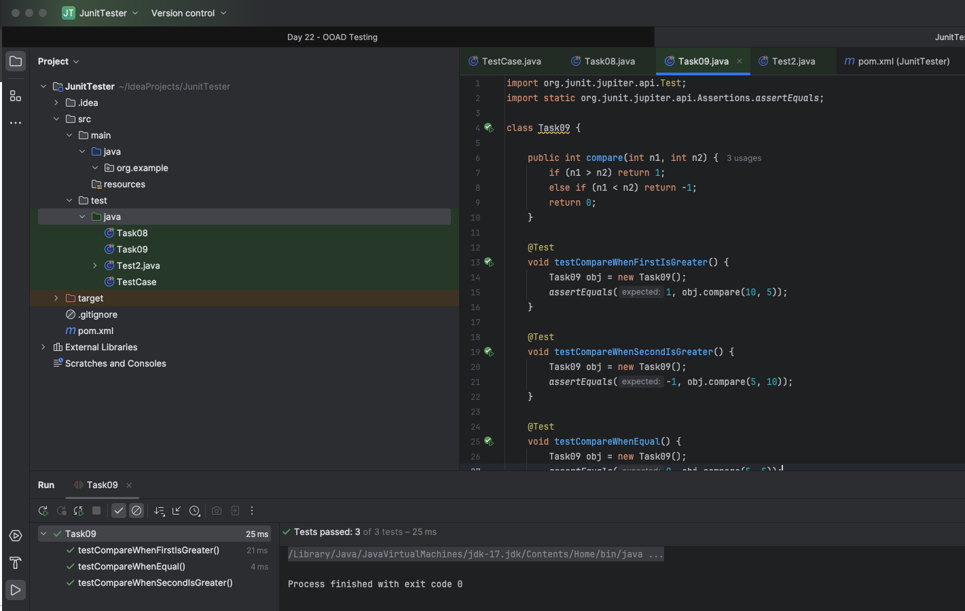

<project xmlns="http://maven.apache.org/POM/4.0.0"
xmlns:xsi="http://www.w3.org/2001/XMLSchema-instance"
xsi:schemaLocation="http://maven.apache.org/POM/4.0.0 https://maven.apache.org/xsd/maven-4.0.0.xsd">

<modelVersion>4.0.0</modelVersion>

<groupId>com.example</groupId>
<artifactId>junit5demo</artifactId>
<version>0.0.1-SNAPSHOT</version>

<dependencies>
<dependency>
<groupId>org.junit.jupiter</groupId>
<artifactId>junit-jupiter</artifactId>
<version>5.10.0</version>
<scope>test</scope>
</dependency>
</dependencies>
<build>
<plugins>
<plugin>
<groupId>org.apache.maven.plugins</groupId>
<artifactId>maven-surefire-plugin</artifactId>
<version>3.1.2</version>
<configuration>
<includeTags>firstPriority,fastTag</includeTags>
<excludeTags>slowTag</excludeTags>
</configuration>
</plugin>
</plugins>
</build>

</project>

